Hockey Canada
Make Ethical Decisions:
Coach Workbook
Version 1.0, 2022

Table of Contents
The Ideal Coach 4
Legal Implications 5
The 6-step Ethical Decision-making Process 6
Appendix A: Negligence and Liability 22
Appendix B: Legislative Authorities 24

The Ideal Coach
Create a list of at least 20 characteristics that describe the ideal coach, and identify why each characteristic is important to coaching. For example, a coach has big ears to facilitate good listening skills.

Legal Implications
The Learning Facilitator will read aloud, one at a time, two or three scenarios. Use the space below to describe the scenario and make notes on it.
Scenario:

Notes:

Scenario:

Notes:

Scenario:

Notes:

After each one, discuss whether you believe it’s a legal decision, an ethical decision, or a day-to-day situation.
Note: To find out what you might be liable for in certain situations, see Appendix A: Negligence and Liability for that information.
Note: The laws governing coaching behavior are specific to the province or territory where the coaching occurs. To find out more about this, see Appendix B: Legislative Authorities.

The 6-step Ethical Decision-making Process

TO PLAY OR NOT TO PLAY
Read the situation below, called To Play or Not to Play. Then complete the tasks on the following pages to work through the 6-step ethical decision-making process and resolve the situation.
Jamie has just been named the head coach of her sport organization. Recently, she has noticed that one of the athletes seems to suffer from a knee injury. She brings the situation up with the parents of this 13-year old athlete, whom she knows very well. They say that they are aware of the situation and that they have called their family doctor. The physician was away but, during a telephone conversation, told them not to worry since “this is normal for growing children” and “there should not be any risk”.
The coach speaks with the athlete who confirms that he hurts a bit, but that he will be ready for the championships that are scheduled in a few days. The athlete has a lot of talent and his name is on the provincial coach’s list of potential new recruits.
The athlete’s parents are both members of the organization’s Board of Directors and they are responsible for hiring and assessing coaches. Club policy dictates that it is the coach who ultimately decides whether or not an athlete will take part in a competition. Another policy dictates that an injured athlete cannot compete, and that a written confirmation declaring that the athlete is fit to return to competition must be obtained from a medical doctor.
Since her last discussion with the athlete and the parents, the coach has read a recent sport medicine article dealing with the possible long-term consequences of this type of injury if the first warning signs are ignored. She has also spoken to a sport physician who strongly suggests to not take any chances in this situation, and to consult a specialist as soon as possible. These verifications confirm the signs she had observed in the athlete.
One hour before the beginning of the competition, the parents talk to the coach. They repeat what their family doctor has said, and guarantee that, first thing tomorrow morning, she will have the required letter confirming that the child is fit to compete. The athlete mentions that the pain has increased since last time, but that he is ready to compete if the parents and the coach give the go ahead. The parents insist that their child competes because (1) he wants to and says he can, and (2) the provincial team coach has made a two-hour trip to come and see him compete in order to confirm his selection. The parents leave the coach, and walk towards the registration table with their child.

Step 1 — Establish the facts.
Read the selection below, and then complete the table below it.
Step 1 — Establish the Facts in a Situation | When faced with any situation or problem in coaching, you must establish exactly what has happened (or is happening) and who is involved in the situation before trying to figure out what to do about it.  At this stage, ask yourself the following questions:  - What has happened or what is happening?  - When and where did certain events occur?  - Who is (or might be) involved in or concerned by the situation?  - What do the parties involved have to say about the situation (i.e. what are all sides of the story)? Get the facts from all the parties involved, and look at the situation from both sides if there is disagreement or conflict.
Facts

Step 2 — Determine whether the situation involves legal or ethical issues.
Read the selection below, and then complete the table on page 10.
Step 2 — Determine Whether the Situation Involves Legal or Ethical Issues | A. Does the Situation Have Legal Implications?  Once the facts have been clearly established, the next step consists of determining whether the situation has legal implications. Two useful questions to ask yourself at this stage are:  - Has anyone been harmed by the action or decision of another, and if so, in what way?  - Does the action or the situation contravene an existing law?

Examples of Situations that Have Legal Implications
- Actions that are criminal or quasi-criminal — These are wide ranging and could include theft, assault, sexual assault, other sexual offences, possession of narcotics, underage drinking, driving without a licence or insurance, forgery, fraud, vandalism, etc.
- Actions that breach a contract — These could include someone acting outside the scope of his or her delegated authority, violating agreed-on rules relating to the use of a facility or equipment, or failing to meet other contractual obligations.
- Actions or information indicating there are reasonable grounds to believe that a child may be in need of protection.
- Actions that are discriminatory — Actions of a government, organization, or individual that are contrary to the Canadian Charter of Rights and Freedoms, the Canadian Human Rights Act, or any provincial or territorial human rights legislation.
- Actions that constitute harassment — Harassment is a form of discrimination and is contrary to human rights laws; in its extreme form, harassment may be a criminal offence.
- Actions, even those that are not intentional, that could constitute negligence, as legally defined.

Actions to Take in Situations that Have Legal Implications
A coach occupies a position of authority; accordingly, he or she has important legal responsibilities. When a coach is confronted by a legal situation such as those described previously, he or she has a duty to do something about it.
This would involve:
- Reporting the situation to the police, where the coach is aware of or reasonably suspects criminal or quasi-criminal activity.
- Reporting the situation to child protection authorities, where a coach suspects that a child has suffered physical or emotional harm or is in circumstances where a risk of such harm exists.
- Reporting the matter to the employer or to the organization having authority over the persons involved in the conduct for all other legal matters.

B. Does the Situation Have Ethical Implications?
Law and ethics are related and overlap, but they are not identical. Conduct that is illegal is always unethical. Yet some forms of conduct may be unethical even though they are legal. The law therefore represents an absolute minimum standard of behaviour, while the standard for ethical behaviour is somewhat higher.
When the coach encounters a situation that does not violate any law but raises moral questions, he or she must make decisions about how best to respond. Under these circumstances, ethical principles are often called upon.

When can a coach know that a situation has ethical implications?
Ethical conduct can be described as a behaviour that meets accepted standards or principles of moral, professional, or just conduct. Unethical behaviour is the contrary, i.e. actions or decisions that are immoral, unprofessional or unjust.
Once you have determined that the situation is not of a legal nature, it is important to determine whether it presents an ethical issue. At this stage, ask yourself the following question:
In this situation and given the facts that have been identified, do you feel there is an issue with any of the following:
- Health and safety of athletes at stake now or in future?  - Competition site safety  - Emergency preparedness  - Unnecessary risk to athletes  - Authority being exercised or the best interests of the athletes being considered  - Self-esteem of athletes  - Conflict of interest  - Competency, qualification, certification, or scope of practice  - Loyalty, keeping of commitments, or keeping of one’s word  - Privacy or confidentiality | - Harassment  - Equity and equality  - Level of respect and dignity afforded individuals  - Breaking an organization rules or policies  - Violation of the rules and regulations of sport  - Fair play  - Dignity and self-control in personal behaviour  - Respect accorded to officials and their decisions

 | At this stage, any statement from the above list that you have checked should cause you to believe that there are one or more ethical issues in the situation. Moreover, the checked statements often indicate the ethical aspects that may be at play.

Are there legal implications?

Step 3 — Identify your options and possible consequences and Step 4 — Evaluate your options.
Read the selections below, and then complete the table on pages 16-17.
Step 3 — Identify Your Options and Possible Consequences | Because they often relate to sensitive issues, ethical situations may generate some degree of emotional reaction. As a result, some individuals may have a tendency to react quickly and spontaneously and to make quick decisions. Sometimes, this may affect their judgment and the quality of the decisions they make.
Having determined that the situation does have some ethical implications and identified some potential ethical issues (based on the statements listed in the previous step), you should now identify options for decision or for action and assess potential consequences in each case. This reflection represents an important step in the ethical decision-making process because it shows that you care about what might happen to others.
Start by asking yourself: What could I do in this situation? In the process of answering this question, think about a variety of options. The first one to consider should be not making any decision or taking no action. This would be the least demanding option, and it could be thought of as representing one end of a continuum of possibilities. As a second step, consider the other extreme of the continuum, and think of the most comprehensive or liberal action you might take in the situation. Then, identify several intermediate options. Do not rule out any option at this stage, even though at the outset it may appear an unlikely choice.

Continuum of Options for Decision or Action
Do nothing or make no decision
Most comprehensive or liberal action or decision that can be made
Intermediate options
Once several options for decision have been identified, think about What might happen if. This will enable you to assess the possible consequences of each option. In many ethical situations where a “Yes – No” decision must be made, the following questions are likely to arise:
- What might happen if the coach chose not to make any decision or took no action?
- What might happen if the coach’s position were favourable to the situation, question, or issue at hand?
- What might happen if the coach’s position were not favourable to the situation, question, or issue at hand?

Factors That May Influence Decision-making in An Ethics Situation
The decisions we make may be affected by various influences that we are not always fully aware of. When we must take a position or make a decision in a situation with moral or ethical implications, it is important to get some perspective to be as objective as possible.
To achieve such objectivity, it is useful to reflect on the various factors that may affect our decisions. This enables us:
- To become aware of any factor or factors that seem to affect our way of thinking or of seeing the facts of the situation
- To take into account any such factors in a conscious and rational way when analyzing or deciding
- To draw a more complete picture of the consequences that may arise from the potential decisions
- To better understand the importance we seem to attach to certain outcomes.
For the purposes of this reflection, we may consider two major types of influence:
- Factors arising from internal influences
- Factors arising from external influences

Factors Arising from Internal Influences
Internal influences are intimately linked to the person making the ethical decision. Among their sources:

Previous Experience
- Have you been in a similar situation before? If so, what did you do and was the situation resolved?
- How did you learn to react when faced with such situations?
- How might your level of experience affect your ability to make a fair and reasonable decision?

Personal Values
- How would your family have perceived such a situation?
- What did you learn from your family, your immediate environment, or school about the type of situation you are confronted with?
- How might your cultural origins or your spiritual or religious values influence the way you assess information?

Personal Circumstances
- Could this decision affect your employment? (Could your decision affect a person who has interests vis-a-vis the team or an athlete and who might also be in a position of control, authority, or supervision with respect to you?)
- How might your decision affect the development of your coaching career? (Will your decision have a negative impact on a person who is in a position to make decisions concerning you?)
- How might your decision affect your reputation within the club, the sport, or the situation at hand? (Is there a chance that your decision would change the perception others have of you personally, your methods, or your approaches?)

Factors Arising from External Influences
External factors of influence arise from society or the environment in which the decision maker lives. Some factors:

Economic and Political Aspects
- How might your decision influence the financial situation of your team or club (for example, tobacco or alcoholic beverage sponsorship)?
- What are the influences or political ramifications of your decision (for example, male vs female)?

Gravity of Situation and Urgency of Decision
- To what extent is it important to decide immediately? (For example, is someone’s safety at risk? Is there a tight schedule?)
- Would putting off the decision be prejudicial?
- How many people are affected, who are they, and to what extent are they really affected?

Organisational, Institutional, and Social Aspects
- Are the values of the coach consistent with those of the administration or decision-making levels of the club or sports organization?
- Will the decisions affect members of other organizations? If so, how will relations with them be affected?
- Do the values of the coach reflect those of the community?

Factors That May Influence How You Perceive an Ethics Situation

Chart adapted from Malloy, Ross & Zackus, 2000
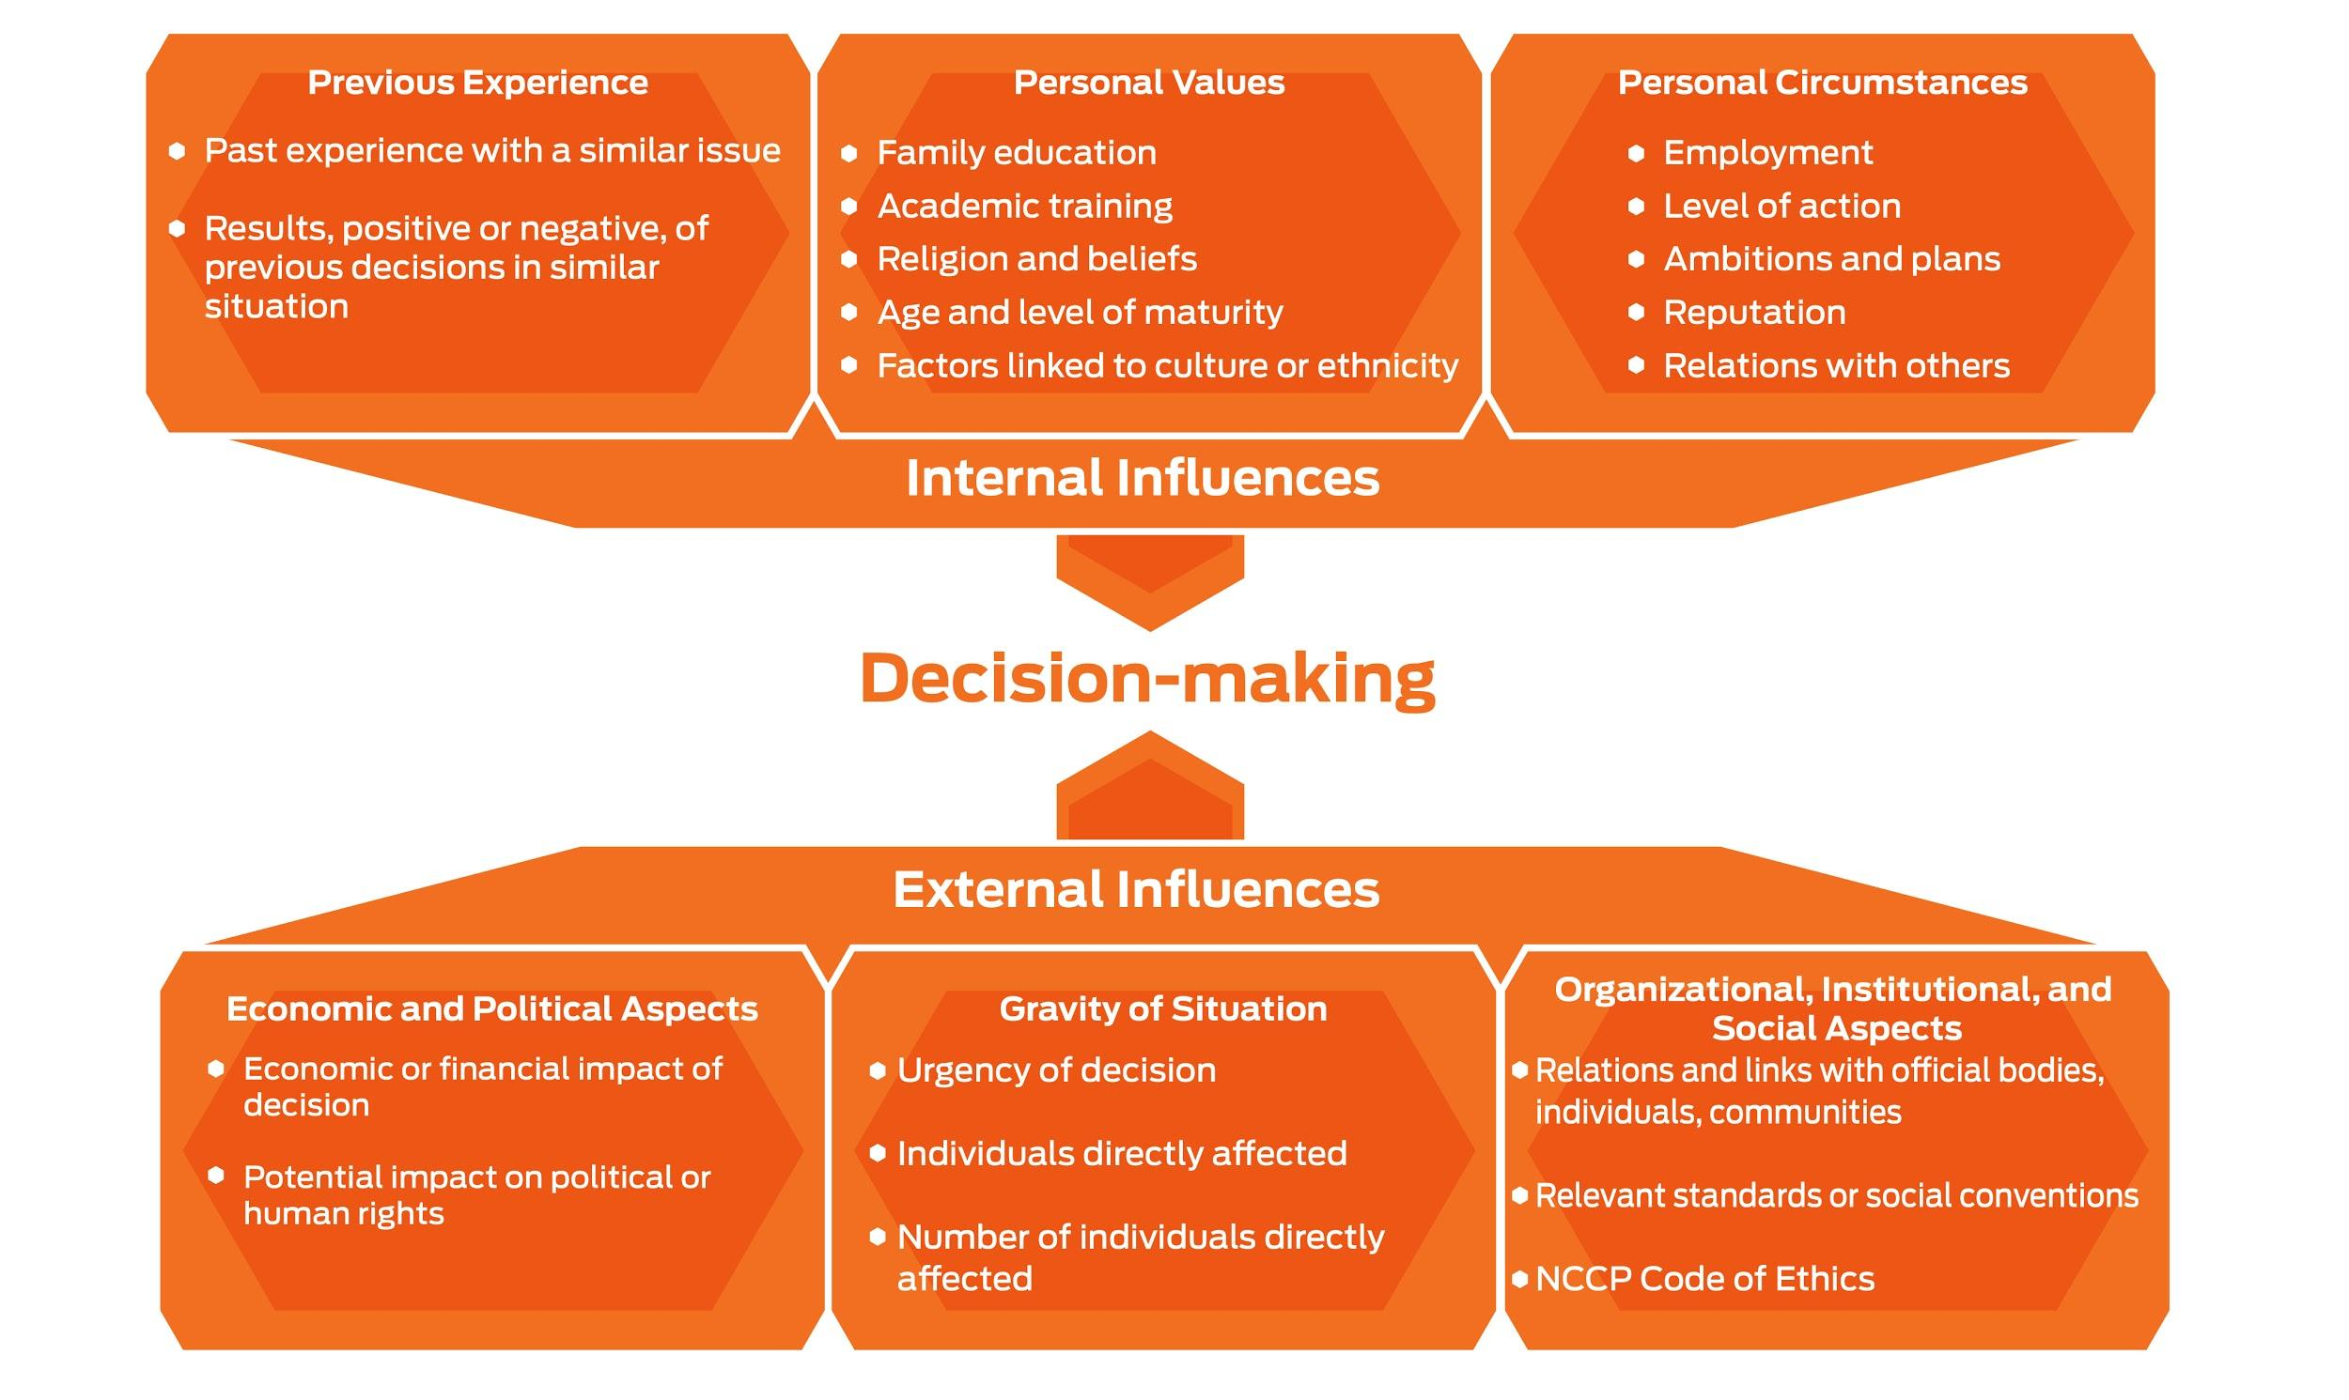

NCCP Code of Ethics

What is a Code of Ethics?
A code of ethics defines what is considered good and right behaviour. It reflects the values held by a group. These values are usually organized into a series of core principles that contain standards of behaviour expected of members while they perform their duties. It can also be used as a benchmark to assess whether certain behaviours are acceptable.

Why a Code of Ethics in Coaching?
Core coaching values have been formalized and expressed as a series of principles in the NCCP Code of Ethics. These principles can be thought of as a set of behavioural expectations regarding participation in sport, coaching athletes or teams, and administering sports.
The NCCP Code of Ethics can help coaches to evaluate issues arising within sport because it represents a reference for what constitutes both “the good and right thing to do”. For example, the code of ethics helps coaches make balanced decisions about achieving personal or team goals and the means by which these goals are attained.

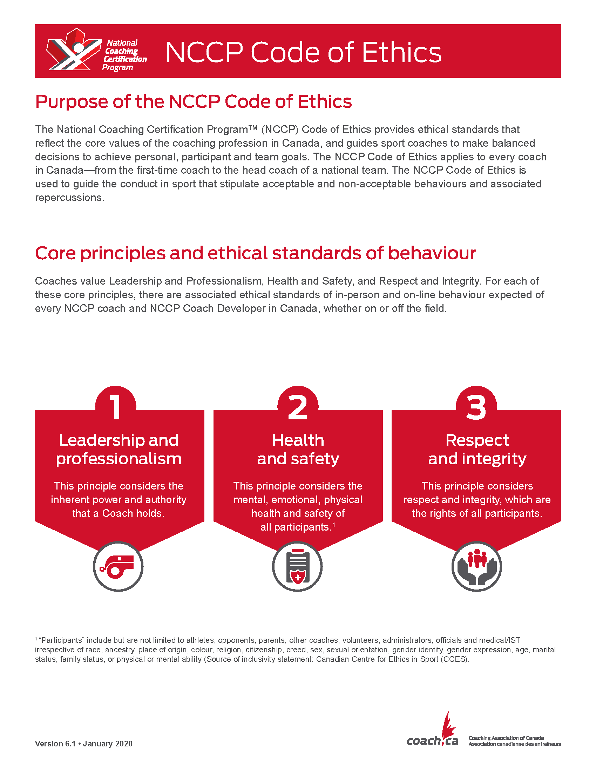

 | 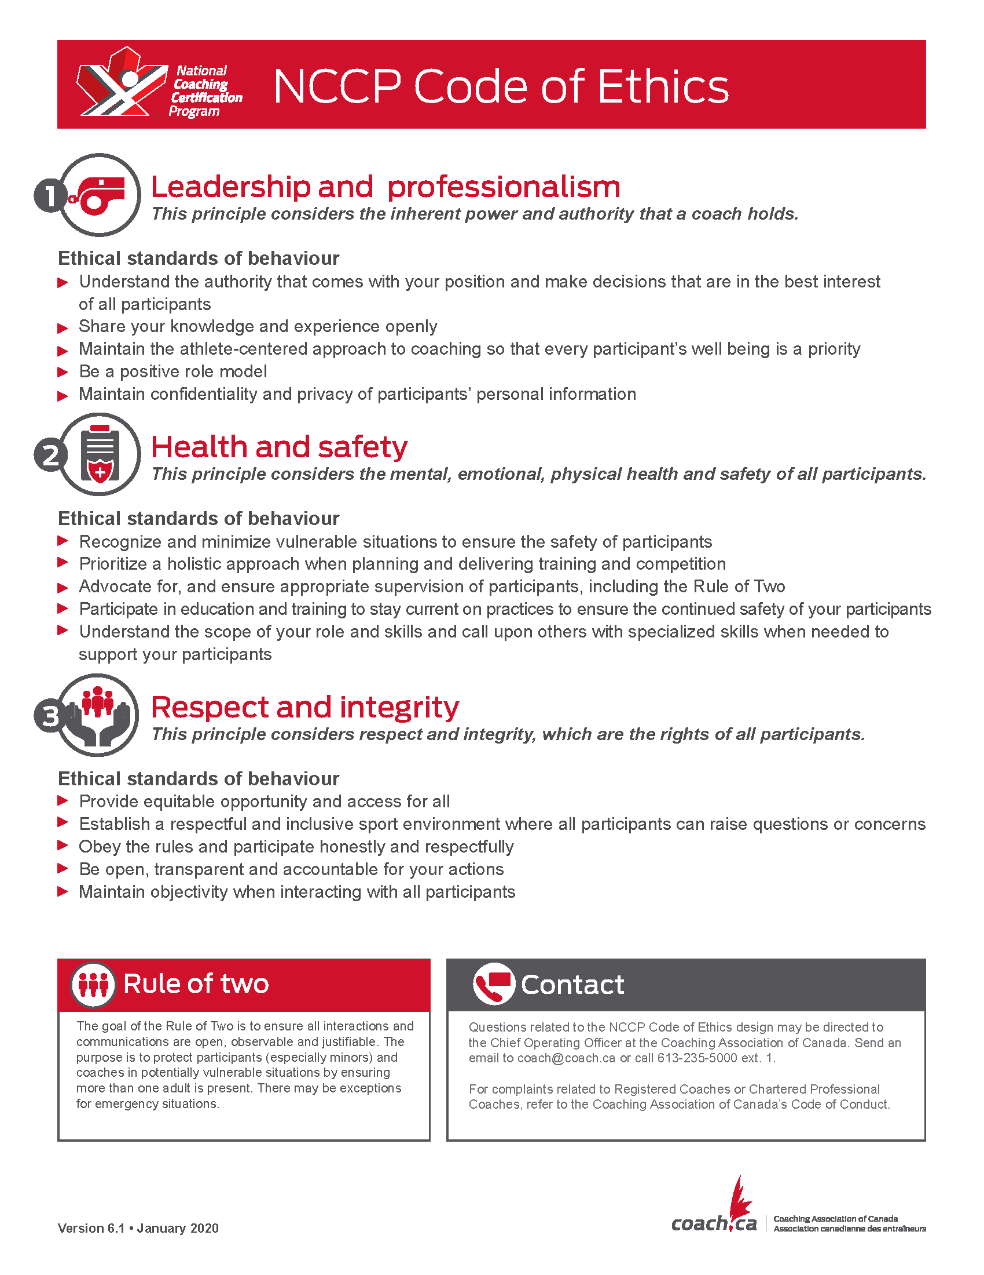

Step 4 — Evaluate Your Options | Once you’ve identified your options and their possible consequences, you need to evaluate them, i.e. assess the pros and cons of each. This is a critical step in reaching a decision.
At this stage, the NCCP Code of Ethics and the fundamental values on which it rests should be important criteria for you to apply when assessing the merits of the options open to you.
The core principles of the NCCP ethics and the associated expected behavioural standards take into account 1) the outcome sought in the decision or action or 2) the means used to reach a decision or guide actions. In some cases, both aspects are present.
The notions of outcome sought (i.e. striving to do what is good for individuals or the team) and means used (striving to do things right) are central to our ethical thinking. Those involved in sport must always keep the following in mind:
- Some of the outcomes we seek may be commendable, but the means to achieve them may not be. For example, a coach could want to preserve the dignity of an athlete who has been mocked (a desirable outcome) by publicly chastising those who made the affront (a dubious way of proceeding for a person in authority).
- Conversely, one could follow a process that appears equitable and consistent with the expectations of those involved but arrive at a problematic outcome in terms of values. For example, a coach could ask members of the team to vote (a means of reaching a decision that appears democratic) to choose between a long-term member whose performances are average or a highly talented newcomer for entry in a competition (a result that would penalize either the team or one of the athletes involved).
 | Coaches’ decisions should reflect a fair balance between outcomes sought and the means used to achieve them

OPTION # | OPTION | CONSEQUENCES
1
2
3
4
5

Step 5 — Choose the best option.
Read the selection below, and then complete the table on page 19.
Step 5 — Choose the Best Option | Making Decisions That Are Just and Reasonable  We are now reaching a crucial phase of our process, i.e. the one where a decision must be made. Steps 1 through 3 of the process provided us with objective information based on issues at play, options for decisions, and potential consequences. In Step 4, we introduced criteria for analyzing the various options using a common reference point: the values of the NCCP Code of Ethics.
Making an ethical decision requires a final reflection on what is the best decision under the circumstances — a just and reasonable decision that will apply where an ethical dilemma is involved. Such a decision:
- Is “the right thing to do” with regard to the duties and responsibilities of the person making the decision
- Is made “the right way”
- Is consistent with the values and behaviours outlined in the NCCP Code of Ethics
However, despite the availability of such criteria, not all ethical decisions are clear-cut. In some instances, a coach may have trouble making a decision because there seems to be more than one reasonable solution. Sometimes, making a decision will even involve sacrificing one value for another. To rank options that seem reasonable with a view to making the best possible decision, we now consider how to do the same for principles to which we adhere, but that appear contradictory in the situation at hand. In other words, what do you do when you are facing an ethical dilemma?

Moral Dilemmas and Ethical Decision-making
Certain ethical situations may generate strong feelings or doubts because there seems to be more than one reasonable solution. Sometimes, making a decision even involves sacrificing one value for another. When there are two potentially right solutions, such situations are referred to as ethical dilemmas — a conflict between values we wish to maintain.
Here are some examples of ethical dilemmas:
- Team rules vs. parental rights and authority. A team has a standing policy of curfew being set at 10:00 PM at away competitions. All parents sign off on this and other policies at the beginning of the year. One parent, who often travels with the team, routinely allows his/her son/daughter to stay up past this hour.
- Team rules vs. winning the competition. A club has a strict policy of no swearing when on clubhouse grounds. The pre-established penalty for such speech is a one-competition automatic suspension. The day before the championship competition, the leading athlete has a temper tantrum during practice and mouths off using foul language to another athlete on the team.
- Do No Harm Principle vs. athlete’s will/rights to play. An athlete has been experiencing chronic knee pain as a result of a growth spurt. The athlete is begging you to be allowed to play in a key competition, and the parents support this athlete in his or her eagerness to play.

Ranking Principles and Values
When someone is faced with an ethical dilemma and is forced to choose between two values, his or her most deeply held beliefs normally dictate the course of action.
If you are faced with an ethical or moral dilemma as a coach, you can resolve the dilemma by asking yourself these questions:
- What does the NCCP Code of Ethics suggest in this type of situation? Which criterion (or value) do you consider the most important from those listed in Step 4?
- Is there another value in which you strongly believe and that you would seek to maintain at all costs? If so, which is it?

Do No Harm Principle
Even though it is a sensitive issue to suggest ranking your values, the NCCP considers that it is a coach’s duty above all to ensure that the decisions he or she makes and the actions he or she takes do not result in harm, physical or other, to athletes.
It therefore follows that in a moral dilemma, physical safety or the health of athletes is the overriding concern.

The challenge in ethical decision-making is to determine which value you will maintain in your course of action.

Validating Your Decision
Setting aside the priority given to athletes’ physical safety and health, one last set of questions may help you validate your chosen option as just and reasonable:
- Would you make this decision in all similar cases?
- If you feel you cannot apply your decision to all similar cases, what might be a reasonable and justifiable exception? If so, in which circumstances? Do such circumstances apply in the present situation? What makes you think that an exception might be justified in this case, but not in other situations?
- Is the decision consistent with decisions made in similar situations in the past that have had positive outcomes?
 | Going through this last series of questions should give you confidence that you’ve made the best possible decision under the circumstances. Answering these questions also gives you sound explanations of your decision.

Best Options

Step 6 — Implement your decision.
Read the selection below, and then complete the table on page 21.
Step 6 — Implement Your Decision | In Steps 1 to 5, you went through a thorough reflection process that has made it possible for you to make a just and reasonable decision in response to an ethical situation. The final step in the ethical decision-making process is to implement your decision.
Putting your decision or plan of action into effect requires that you consider a number of things, particularly if it involves dealing with individuals or groups of people. Consider the following as you establish an action plan:
- Choose your path. Exactly what are you going to do? Plan carefully the steps you are going to take.
- Think about what may happen. Consider the likely outcomes of the decision and the how any consequences will be managed.
- Identify who needs to know. Consider who needs to be informed of or involved in implementing the action plan or decision.
- Determine if you can deal on your own with the person(s) involved. Is it appropriate to seek an informal resolution in this situation? In issues not involving a contravention of the law, it is often best to try to deal with the issue informally and directly with the individual involved. We often refer to this as adopting the conservative approach. It has the advantage of conferring responsibility for actions on the party involved and allows him or her to resolve the situation while maintaining a sense of dignity and self-respect. It also establishes a degree of trust between parties involved. Approach the individual, and tell him or her what you have seen or what has been shared with you. Give him or her a chance to respond, a chance to do the good or right thing.
- Warn, don’t threaten. This is an important concept when dealing with a situation at an informal level. This entails informing the individual of the logical consequences of what can happen if a situation is not resolved, rather than threatening the person with an end run. This is Plan B. Keep any Plan B in your back pocket.
- Think about what you might do next if the chosen plan of action doesn’t work. If your original decision or plan of action is ineffective, think carefully about what to do next. Inform the individual that you now have to follow up with Plan B. Consider who should be contacted and what level of authority you should now involve in this situation.
General Tips about Ethical Decision-making
- When in doubt or faced with an ethical dilemma, think about the Do No Harm principle
- Never second-guess yourself on decisions made with integrity, intelligence, thoroughness, and based on accepted values, core principles, and expected standards of behaviour.
- Make sure you are clear about your coaching values and that you can talk about them in a way that is clear, simple, and easily understood by everyone.
- Cross-reference your coaching values and principles with the NCCP Code of Ethics.
- Pay attention to what is important to kids when establishing your ethical standards.

Who will be affected by your decision? In what order should these individuals/groups be notified? How will you deliver the message(s)?

Appendix A: Negligence and Liability
More than ever before, coaches ought to be aware of the risks and responsibilities they assume when they coach, particularly any legal risks and responsibilities. Coaches have a legal obligation to provide a safe environment for athletes at all times, regardless of the coaches’ certification, experience, employment or volunteer status, sport discipline, or location of residence.
To understand this obligation more fully, coaches must understand some key legal principles, including negligence and liability, and concepts and techniques related to risk management. With this knowledge, coaches can determine the applicable standard of care, assess their own coaching situation for risks, and establish appropriate measures to manage those risks.

Negligence
Negligence is a term with precise legal meaning. The term relates to standards of behaviour that the law expects. Understanding the law of negligence is an essential first step in learning how to provide a safe environment for athletes.
In general terms, negligence refers to a behaviour or an action that falls below a “reasonable standard of care.” The law in Canada demands that we behave in a particular way so that others who might be affected by our actions aren’t exposed to an unreasonable risk of harm. The standard of behaviour coaches are expected to meet is termed an “objective” standard. As adults and as coaches, we’re all credited with the same general intelligence and sensibility, and the law therefore expects each of us to behave in a reasonable fashion in similar situations.
The law doesn’t expect coaches to be perfect in their behaviour; rather, the law expects coaches to be reasonable and act as other reasonable coaches would in the same circumstances. Negligence is therefore the failure to exercise the care that an ordinary, reasonably prudent coach would exercise in the circumstances.
It’s widely accepted that there’s a certain amount of risk in many sport activities, and that such risk is knowable, foreseeable, acceptable, and depending on the sport, even desirable. What’s unacceptable in sport is behaviour that exposes athletes to an objectively unreasonable risk or in danger.
A coach’s conduct is negligent when all 4 of the following occur:
- A duty of care exists (such as the 1 that exists between a coach and an athlete, where the coach is placed in a position of power and trust).
- That duty imposes a standard of care, which may be found under the common law or may be imposed under legislation, which the coach doesn’t meet.
- An athlete or some other person experiences harm.
- The failure to meet the standard of care can be shown to have caused or substantially contributed to the harm.
A coach must go beyond duty of care when there are reasonable grounds to suspect that an athlete is, or may be, an abuse victim and in need of protection. In such cases, a coach has the additional duty to report and the duty to act. This requires that the coach take immediate steps, which include reporting the situation to the proper authorities.
For the coach, the standard of care is the most important of the above elements. The standard of care is what the coach should do in each situation. It’s difficult to precisely define standard of care, because the inherent risk of the surrounding circumstances influences the standard of care. Thus, the duty to act responsibly remains constant, but the specific behaviour required to fulfil that duty changes with the circumstances.
Determining what the standard of care is in any given circumstance involves looking to 4 sources:
- Written standards – These are government regulations, equipment standards, rules for a sport or facility, rules from a sport governing body, coaching standards and codes of conduct, and other internal risk-management policies and procedures.
- Unwritten standards – These are norms or conventions that might not be written down. They’re nonetheless known, accepted and followed in a sport, an organization or a facility.
- Case law – These are court decisions about similar situations. Where the circumstances are the same or similar, judges must apply legal principles in the same or similar ways. Earlier decisions of the court are a guide, or precedent, for future decisions where the facts are similar.
- Common sense – This means simply doing what feels right or avoiding doing what feels wrong. Common sense is the sum of a person’s knowledge and experience. Trusting one’s common sense is a good practice.
The responsible and prudent coach is familiar with written policies that govern coaches, is aware of unwritten norms and practices, knows something of the case law as it applies to coaches, and has learned to trust intuitive judgment and common sense.

Liability
A coach’s negligence may be established when all 4 conditions are met of negligence’s legal definition. What follows next is the question of liability. While negligence refers to conduct, liability refers to responsibility for the consequences of negligent conduct. Responsibility may lie with the coach who was negligent or with another person or entity.
For example, an insurance policy transfers the financial liability for negligence to an insurance company. A valid waiver of liability agreement might eliminate liability entirely. An injured athlete may be partially responsible for their injuries and thus may share liability with the negligent coach. And a sport organization may be liable for the negligent actions of its coach who is either an employee or a volunteer. Vicarious liability is a doctrine that imposes liability on an employer for employee wrongdoings.
However, vicarious liability doesn’t serve to entirely eliminate the coach’s own personal liability, particularly when the wrongdoing isn’t connected to the coach’s duties or scope of employment. Accordingly, the organization and the coach may share liability for the coach’s negligent actions. It’s expected that the coach will at all times be proactive in helping to manage liability.
Negligence isn’t the only action or behaviour that might trigger liability. Liability can also refer to responsibility for the consequences of conduct, which fail to meet a predetermined legal standard, other than the standard of care in a situation where negligence occurs. Liability can arise when a law is broken or a contract is breached. The prudent coach avoids these types of liability by obeying laws and complying with contractual agreements.
In sum, an understanding of the legal meaning of negligence answers the coach’s question: How does the law expect me to behave? The follow-up question is: How can I be sure that my behaviour will meet this expectation? The answer to this question lies in risk management.

Appendix B: Legislative Authorities
Below is a list of the federal, provincial and territorial laws that apply to the scenarios with a legal implication presented below.
Scenario #1: A coach tells his group of boys that they throw like “a bunch of girls.”
Harassment is any single incident or repeated incidents of objectionable or unwelcome conduct, comment, bullying or action by a person that would cause offence or humiliation to an individual, or that would adversely affect the individual’s health and safety.
Each Canadian province and territory has its own occupational health and safety legislation and regulations, which legislate that steps must be taken to ensure the safety of employees and other persons present in the workplace. Some of them have specific provisions addressing harassment.
In Quebec, psychological harassment is addressed under labour standards legislation that obliges employers to prevent psychological harassment and resolve problems brought to their attention.
- Alberta: Occupational Health and Safety Act, SA 2017, c O2.1, s 5
- British Columbia: Workers Compensation Act, RSBC 1996, c 492, s 116 and Policy Item D31152
- Manitoba: The Workplace Safety and Health Act, CCSM c W210, s 5 and Workplace Safety and Health Regulation, Man Reg 217/2006, s 10
- New Brunswick: Occupational Health and Safety Act, SNB 1983, c O0.2, s 12 and General Regulation, NB Reg 91191 (effective April 1, 2019)
- Newfoundland and Labrador: Occupational Health and Safety Act, RSNL 1990, c O3, s 7
- Northwest Territories: Safety Act, RSNWT 1988, c S1, s 5
- Nova Scotia: Occupational Health and Safety Act, SNS 1996, c 7, s 7
- Nunavut: Safety Act, RSNWT (Nu) 1988, c S1, s 5
- Ontario: Occupational Health and Safety Act, RSO 1990, c O.1, s 28(1) and s. 32.0.7
- Prince Edward Island: Occupational Health and Safety Act, RSPEI 1988, c O1.01, s 16
- Quebec: Act respecting labour standards, CQLR c N1.1, s 81.19
- Saskatchewan: The Occupational Health and Safety Regulations, 1996, RRS c O1.1 Reg 1, s 13 and s 36
- Yukon: Occupational Health and Safety Act, RSY 2002, c 159, s 9
Scenario #2: You overhear your athletes on the bench making fun of another teammate’s accent.
All Canadian provinces and territories have human rights laws with specific agencies that allow them to enforce legislation. While not all offer the same human rights protections, discrimination based on ancestry, nationality, place of origin, or on national, ethnic or linguistic background or origin is generally prohibited across the entire country.
- Canada: Canadian Human Rights Act, RSC 1985, c H6, s 3(1)
- Alberta: Alberta Human Rights Act, RSA 2000, c A25.5, s 4
- British Columbia: Human Rights Code, RSBC 1996, c 210, s 8
- Manitoba: The Human Rights Code, CCSM c H175, s 9(2)
- New Brunswick: Human Rights Act, RSNB 2011, c 171, s 2(1)
- Newfoundland and Labrador: Human Rights Act, 2010, SNL 2010, c H13.1, s 9(1)
- Northwest Territories: Human Rights Act, SNWT 2002, c 18, s 5(1)
- Nova Scotia: Human Rights Act, RSNS 1989, c 214, s 5(1)
- Nunavut: Human Rights Act, SNu 2003, c 12, s 7(1)
- Ontario: Human Rights Code, RSO 1990, c H.19, s 1
- Prince Edward Island: Human Rights Act, RSPEI 1988, c H12, s 1(1)
- Quebec: Charter of Human Rights and Freedoms, CQLR c C12, s 10
- Saskatchewan: Saskatchewan Human Rights Code, 2018, SS 2018, c S24.2, s 2(1)
- Yukon: Human Rights Act, RSY 2002, c 116, s 7
Scenario #3: As punishment for losing a game, a coach has her athletes perform laps until they’re at the point of exhaustion.
Under child protection legislation, coaches must look out for indications that there are reasonable grounds to believe that a child may be in need of protection due to risk of unusual treatment or punishment.
- Alberta: Child, Youth and Family Enhancement Act, RSA 2000, c C12, s 1(2)
- British Columbia: Child, Family and Community Service Act, RSBC 1996, c 46, s 13(c)
- Manitoba: The Child and Family Services Act, CCSM c C80, s 17(2)
- New Brunswick: Family Services Act, SNB 1980, c F2.2, s 31(1)
- Newfoundland and Labrador: Children and Youth Care and Protection Act, SNL 2010, c C12.2, s 10(1)
- Northwest Territories: Child and Family Services Act, SNWT 1997, c 13, s 7(1)
- Nova Scotia: Children and Family Services Act, SNS 1990, c 5, s 22(2)
- Nunavut: Child and Family Services Act, SNWT 1997, c 13, s 7(1)
- Ontario: Child, Youth and Family Services Act, 2017, SO 2017, c 14, Sch 1, s 4
- Prince Edward Island: Child Protection Act, RSPEI 1988, c C5.1, s 9
- Quebec: Youth Protection Act, CQLR c P34.1, s 38
- Saskatchewan: The Child and Family Services Act, SS 1989-90, c C7.2, s 11
- Yukon: Child and Family Services Act, SY 2008, c 1, s 21
Scenario #4: When you ask about bruises on an athlete’s body, she says her older cousin regularly beats her up.
See scenario #3. In addition, most acts of violence are crimes in Canada under the Criminal Code including assault causing bodily harm.
- Canada: Criminal Code, RSC 1985, c C-46, s 265
Scenario #5: The competitive team coach holds weekly weigh-ins for the athletes and emails everyone’s results to the entire team.
The Personal Information Protection and Electronic Documents Act (PIPEDA) governs how businesses collect, use, and disclose personal information in the course of their activities in all provinces and territories across Canada, with the sole exception of Alberta, British Columbia and Quebec, which have enacted provincial legislation deemed substantially similar to the PIPEDA.
Personal information includes a wide range of factual or subjective information about an individual including age, weight, employee files and medical records.
Although the PIPEDA most frequently applies to for-profit organizations engaged in commercial activities, non-profit status doesn’t automatically exempt an organization from the legislation’s application.
- Canada: Personal Information Protection and Electronic Documents Act, SC 2000, c 5, s 7(3)
- Alberta: Personal Information Protection Act, SA 2003, c P6.5, s 7(1)
- British Columbia: Personal Information Protection Act, SBC 2003, c 63, s 6
- Quebec: Act respecting the protection of personal information in the private sector, CQLR c P39.1, s 10
Scenario #6: A 20-year-old assistant coach starts dating a 16-year-old athlete in your club.
Although the age of consent is 16 years in Canada, it’s higher when the sexual partner is in any position of trust or authority toward the minor. For instance, a position of trust or authority is the case with a relationship between a young athlete and their coach.
- Canada: Criminal Code, RSC 1985, c C46, s 153(1)
Scenario #7: A coach shares another coach’s personal medical information with several athletes on the team.
See Scenario #5.
Scenario #8: A coach insists that an athlete compete, even though the athlete is recovering from injury and is reluctant to do compete.
See Scenario #3. Under child protection law, coaches must also look out for indications that there are reasonable grounds to believe that a child may be in need of protection due to a risk of physical injury, as is the case here.
Scenario #9: A coach always arrives late, with coffee in hand, and spends most of the practice playing around on his phone.
- No applicable legislative authority.
Scenario #10: One of the other coaches has obvious “favourites,” and gives them extra time and attention.
- No applicable legislative authority, although treating some people differently than others can ultimately lead to a finding of harassment. See scenario #1.

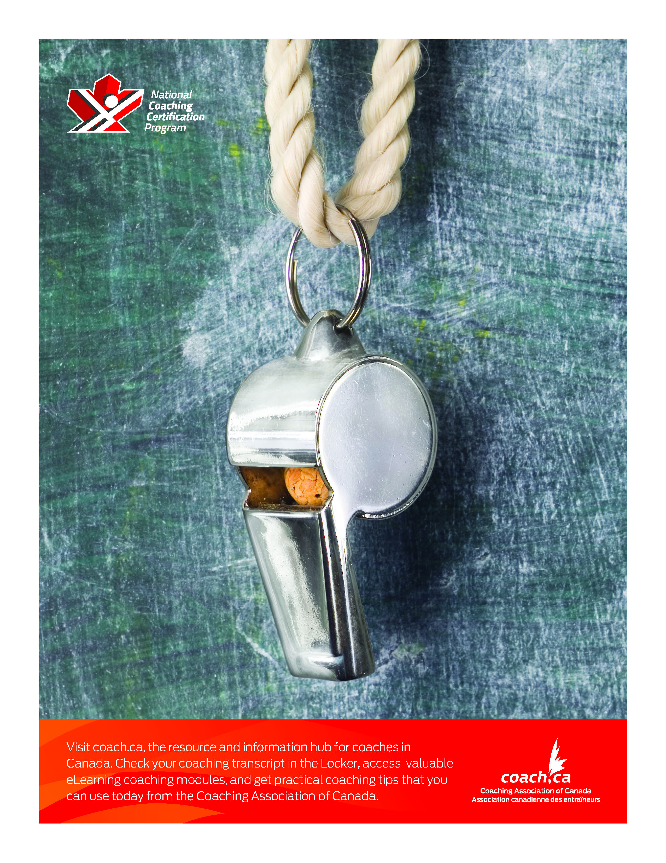

Malloy, D. C., Ross, S., & Zakus, D. H. Sport Ethics: Concepts and Cases in Sport and Recreation. Thompson Educational Publishing. 2000. ISBN 155077107.

